|  |  |  |
| --- | --- | --- |
| **Ultrasonic sensor** |  | **UBS2000-30GM-IUR2-V15** |
| **Technical data** |  | |  | | --- | |  | | |
| General Specifications |  |
| Sensing distance | 80…2000mm |
| Adjustment range | 80…2000mm |
| Unusable area | 0…80mm |
| Standard target plate | 400mm×400mm |
| Transducer frequency About | 180 kHz |
| Response delay About | 125ms |
| **Indicators/Operating means** |  |
| LED blue | solid: object in evaluation range |
| **LED red** |  |
| Electrical specifications |  | |  | | --- | |  | | |
| **Operating voltage U**B | 10…30VDC ripple10%ss |
| No-load supply current | ≤20mA |
| **Output** |  |
| Output type | 1 analogue output 4 -- 20mA |
| **Resolution** |  |
| Deviation of the characteristic  curve | ±1% of full-scale value |
| Repeat accuracy | ±0.1% of full-scale value |
| Load impedance | <500 Ohm |
| **Maximum switching current** |  |
| Temperature influence | ±1.5% of full-scale value |
| **Ambient conditions** |  |
| Ambient temperature | -25…70℃ |
| Storage temperature | -40…85℃ |
| **Mechanical specifications** |  | |  | | --- | |  | | |
| **Protection grade** | IP67 |
| Connection | Connector M12,5-PIN |
| **Material** |  |
| Housing | Brass nickel-plated |
| **Transducer** | epoxy resin/hollow glass sphere  mixture; Polyurethane foam | **1 BROWN：+U 2 WHITE: 0 --- 10V  3 BLUE: -U 4 BLACK: 4 ---20mA**  **5 GREY: SYNC** |
| **Weight** | 80g |
| **Compliance with standards and Directives** | |
| Standard conformity | EN 60947-5-2:2020 |  |

**Synchronization**

This sensor features a synchronization input for suppressing ultrasonic mutual interference ("cross talk").If the input port is not switched on, the sensor operates at the internal frequency. A square wave voltage can also be added to the input port to synchronize the sensor. A synchronization pulse on the synchronization input initiates a measurement cycle. The synchronization pulse width must be greater than 100ms. The measurement period is triggered by the falling edge of the pulse. Because the sensor uses the average of five measurements internally, the switching state changes only when all five measurements exceed the switching threshold. If the low level duration reaches or exceeds 1 second, or if the synchronous input port is suspended, the sensor will operate normally. Synchronization is not allowed during the setting period. Otherwise, learning cannot be performed if synchronization is used. Synchronization can work in two ways.

1. Multiple sensors are triggered by the same synchronization signal and work synchronously.

2. The synchronization pulse is output to a sensor in turn, that is, each sensor works in multiple ways. Adding a high level tothe synchronous input stops the sensor.

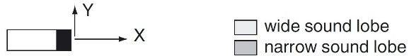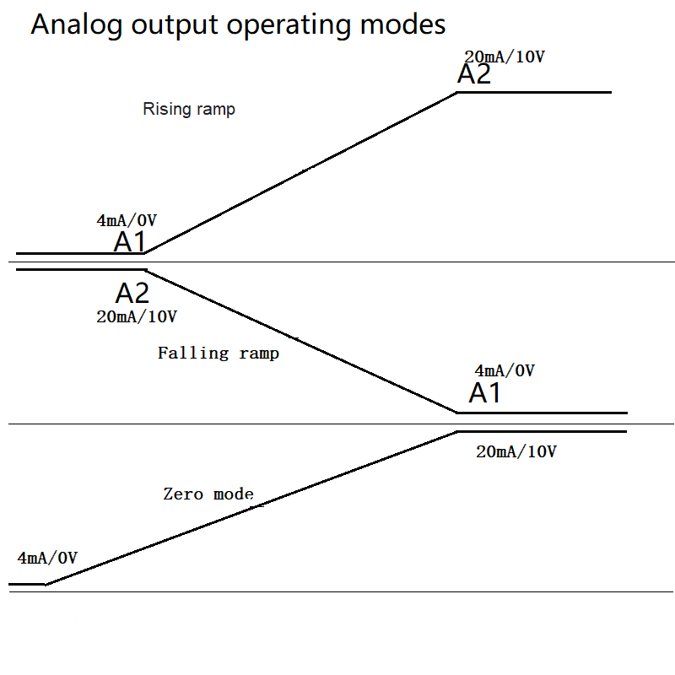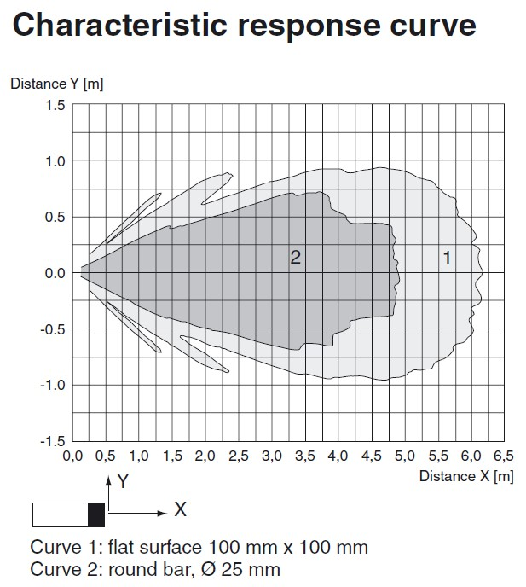

|  |
| --- |
|  |

**Please refer to the attachment for the specific method of setting the far**

**point (A1) and near point (A2)；**