Ultrasonic sensor Ultrasonic sensor UM300-18GM-E5-V1

Technical data | 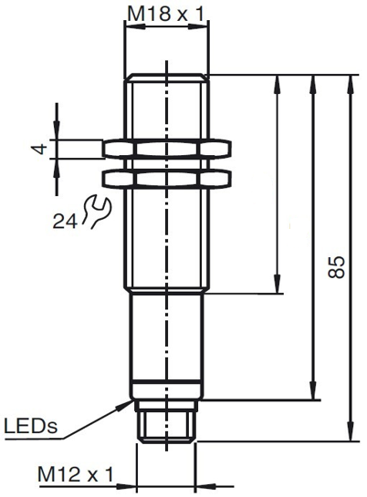  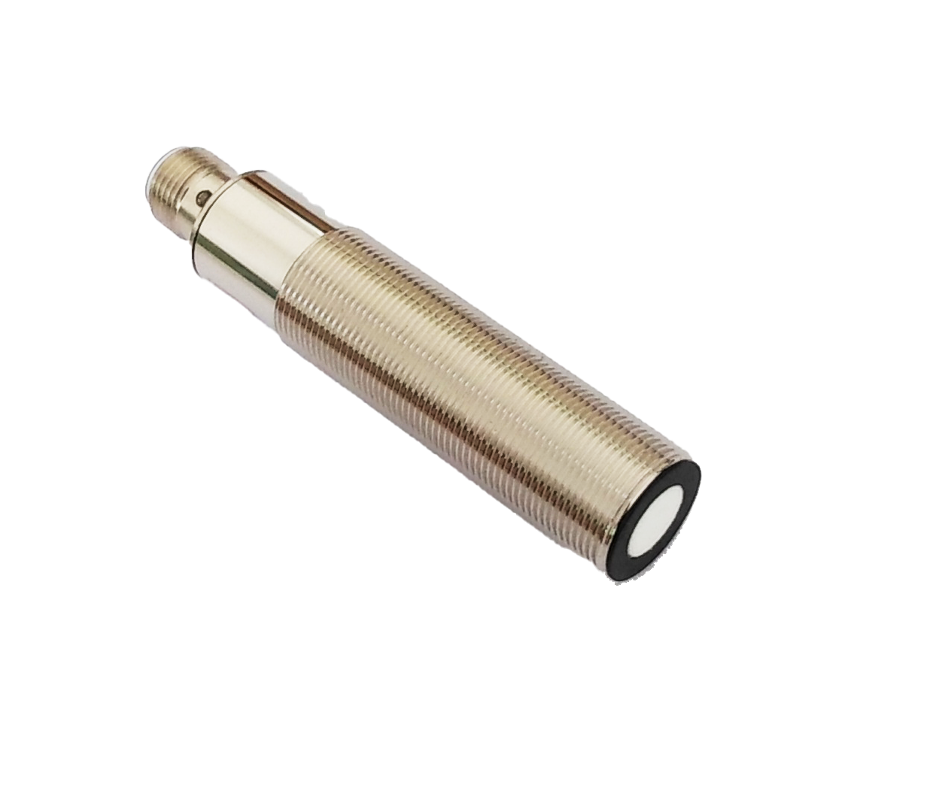
General Specifications
Sensing distance 30…300mm
Adjustment range 30…300mm
Unusable area 0…30mm
Standard target plate 100mm×100mm
Transducer frequency About 300 kHz
Response delay About 65ms
Indicators/Operating means
LED Blue solid: object in evaluation range
flashing: program function object detected
LED Red flashing: fault or program function no object detected
Electrical specifications
Operating voltage U_{B} 10…30VDC,ripple10%ss
No-load supply current ≤15mA
Output
Output type 1 switch output PNP NO/NC,programmable
Resolution 0.11mm at max.sensing range | 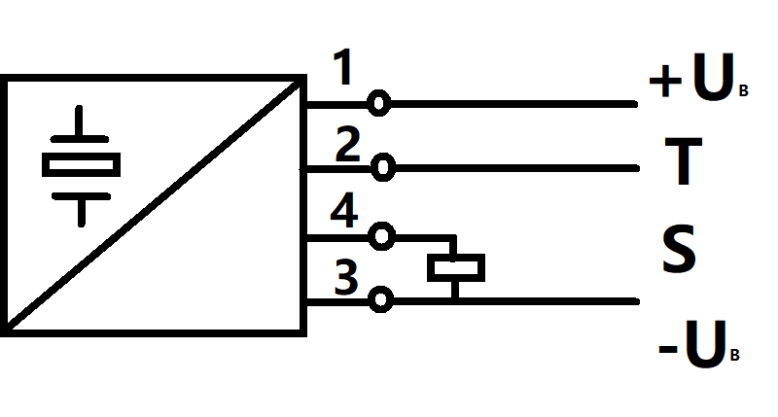
Deviation of the characteristic
curve ±1% of full-scale value
Repeat accuracy ±0.1% of full-scale value
Load impedance >1k Ohm
Maximum switching current 200 mA (reverse polarity protection)
Temperature influence ±1.5% of full-scale value
Ambient conditions
Ambient temperature -25…70℃
Storage temperature -40…85℃
Mechanical specifications
Protection grade IP67
Connection Connector M12x1,4-PIN | 1 BN=BROWN  2 WH=WHITE  3 BU=BLUE  4 BK=BLACK  V1 Connector  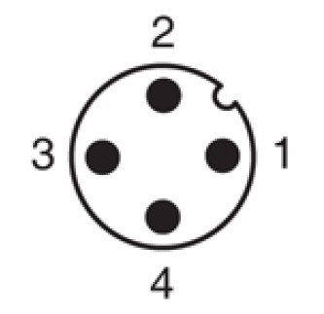
Material
Housing brass,nickel-plated
Transducer epoxy resin/hollow glass sphere mixture;
Polyurethane foam
Weight 50g
Compliance with standards and directives
Standard conformity EN 60947-5-2:2020
Adjusting the switching points
The ultrasonic sensor features a switch output with two teachable switching points. These are set by applying the supply voltage - U_{B} or + U_{B} to the TEACH-IN input. The supply voltage must be applied to the TEACH-IN input for at least 1 s.LEDs indicate whether the sensor has recognised the target during the TEACH-IN procedure. Switching point A1 is taught with - U_{B},A2 with +U_{B.} Five different output functions can be set.
- Window mode, normally-open function.
- Window mode, normally-closed function.
- One switching point,normally-open function
- One switching point,normally-closed function.
- Detection of objet presence.
Switching point, Setting distance only after power on. The internal clock can assure can't be changed after 5 mins when power
on. If want to change the switching point, the user can only setting the request distance after power restart.
TEACH-IN window mode,normally-open function  -Set target to near switching point  -TEACH-IN switching point A1 with - U_{B}  -Set target to far switching point  -TEACH-IN switching point A2 with + U_{B} |  |  | 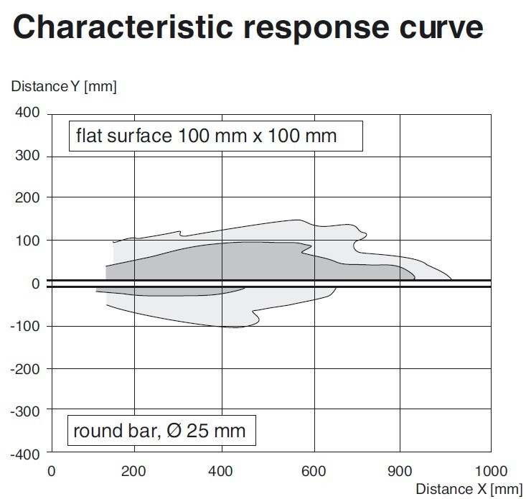
TEACH-IN window mode,normally-closed function
-Set target to near switching point
-TEACH-IN switching point A2 with + U_{B}
-Set target to far switching point
-TEACH-IN switching point A1 with - U_{B}
TEACH-IN switching point, normally-open function
-Set target to near switching point
-TEACH-IN switching point A2 with + U_{B}
-Cover sensor with hand or remove all objects from sensing range
-TEACH-IN switching point A1 with - U_{B}
Curve1:flat surface 100mm×100mm
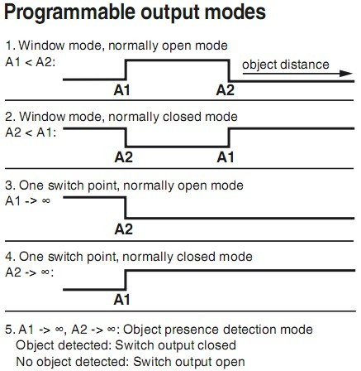
Curve2:round bar,Φ25mm
TEACH-IN switching point, normally-closed function
-Set target to near switching point
-TEACH-IN switching point A1 with - U_{B}
-Cover sensor with hand or remove all objects from sensing range
-TEACH-IN switching point A2 with + U_{B}
TEACH-IN detection of objects presence
-Cover sensor with hand or remove all objects from sensing range
-TEACH-IN switching point A1 with - U_{B}
-TEACH-IN switching point A2 with + U_{B}
Default setting of switching point
A1=blind range,A2=nominal distance
LED displays
Displays in dependence on operating mode | Red LED | Blue LED
TEACH-IN switching point  Object detected  No object detected  Object uncertain(TEACH-IN invalid) | Off  flashes  off | flashes  off  off
Normal operation | off | Switching state
Fault | on | Previous state
Installation conditions
If the sensor is installed at the environment temperature fall below 0℃,It should do well on the protective measures. In case of direct mounting of the sensor in a through hole using the steel nuts, it has to be fixed at the middle of the housing thread.

