Ultrasonic sensor |  | UBS500-18GM-E5-V15
Technical data |  | 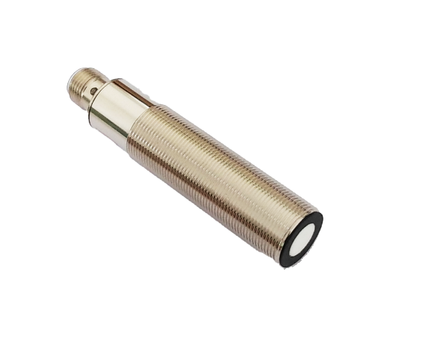
General Specifications
Sensing distance | 50…500mm
Adjustment range | 50…500mm
Unusable area | 0…200mm
Standard target plate | 200mm×200mm
Transducer frequency About | 200 kHz
Response delay About | 85ms
Indicators/Operating means
LED Blue
LED red
Electrical specifications |  | 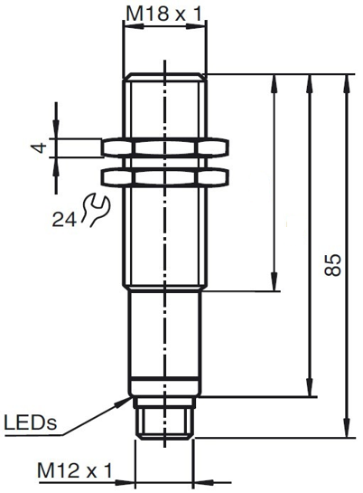
Operating voltage U_{B} | 10…30VDC ripple10%ss
No-load supply current | ≤30mA
Output
Output type | 1 switch output PNP
Resolution
Deviation of the characteristic  curve | ±1% of full-scale value
Repeat accuracy | ±0.1% of full-scale value
Maximum switching current | 200 mA
Maximum switching current
Temperature influence | ±1.5% of full-scale value
Ambient conditions
Ambient temperature | -25…70℃
Storage temperature | -40…85℃
Mechanical specifications |  | 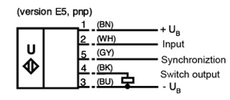
Protection grade | IP65
Connection | Connector M12,5-PIN
Material
Housing | Brass nickel-plated
Transducer | epoxy resin/hollow glass sphere  mixture; Polyurethane foam | 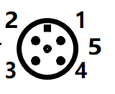  1 BROWN：+U  2 WHITE: TECH IN  3 BLUE: -U  4 BLACK: OUTPUT  5 GREY: SYNC
Weight | 50g
Compliance with standards and Directives
Standard conformity | EN 60947-5-2:2020

Synchronization
This sensor features a synchronization input for suppressing ultrasonic mutual interference ("cross talk"). If the input port is not switched on, the sensor operates at the internal frequency. A square wave voltage can also be added to the input port to synchronize the sensor. A synchronization pulse on the synchronization input initiates a measurement cycle. The synchronization pulse width must be greater than 100ms. The measurement period is triggered by the falling edge of the pulse. Because the sensor uses the average of five measurements internally, the switching state changes only when all five measurements exceed the switching threshold. If the low level duration reaches or exceeds 1 second, or if the synchronous input port is suspended, the sensor will operate normally. Synchronization is not allowed during the setting period. Otherwise, learning cannot be performed if synchronization is used. Synchronization can work in two ways.
1. Multiple sensors are triggered by the same synchronization signal and work synchronously.
2. The synchronization pulse is output to a sensor in turn, that is, each sensor works in multiple ways. Adding a high level tothe synchronous input stops the sensor.

Adjusting the switching points
The ultrasonic sensor features a switch output with two teachable switching points. These are set by applying the supply voltage - U_{B} or + U_{B} to the TEACH-IN input. The supply voltage must be applied to the TEACH-IN input for at least 1 s. Switching point A1 is taught with - U_{B},A2 with +U_{B.} Five different output functions can be set.
- Window mode, normally-open function.
- Window mode, normally-closed function.
- One switching point,normally-open function
- One switching point,normally-closed function.
- Detection of objet presence.
Switching point, Setting distance only after power on. The internal clock can assure can't be changed after 5 mins when power
on. If want to change the switching point, the user can only setting the request distance after power restart.
TEACH-IN window mode,normally-open function  -Set target to near switching point  -TEACH-IN switching point A1 with - U_{B}  -Set target to far switching point  -TEACH-IN switching point A2 with + U_{B} | 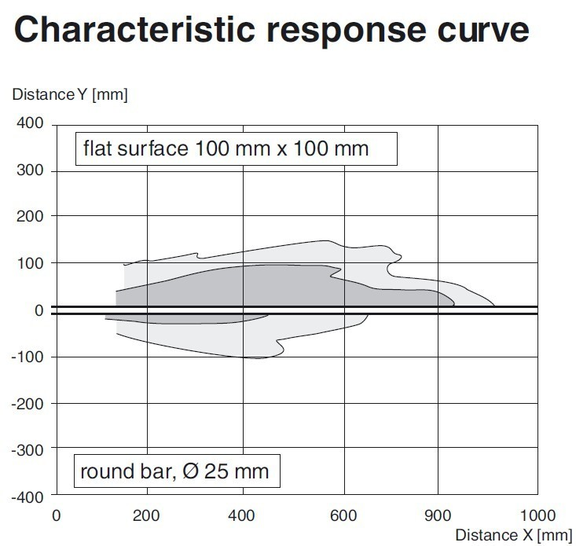
TEACH-IN window mode,normally-closed function
-Set target to near switching point
-TEACH-IN switching point A2 with + U_{B}
-Set target to far switching point
-TEACH-IN switching point A1 with - U_{B}
TEACH-IN switching point, normally-open function
-Set target to near switching point
-TEACH-IN switching point A2 with + U_{B}
-Cover sensor with hand or remove all objects from sensing range
-TEACH-IN switching point A1 with - U_{B}
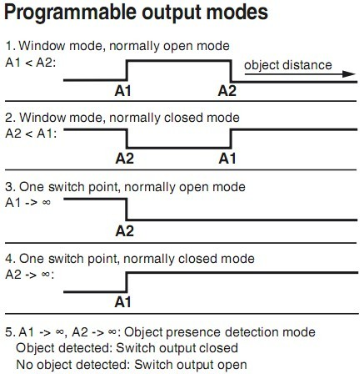
Curve1:flat surface 100mm×100mm
Curve2:round bar,Φ25mm

TEACH-IN switching point, normally-closed function
-Set target to near switching point
-TEACH-IN switching point A1 with - U_{B}
-Cover sensor with hand or remove all objects from sensing range
-TEACH-IN switching point A2 with + U_{B}
TEACH-IN detection of objects presence
-Cover sensor with hand or remove all objects from sensing range
-TEACH-IN switching point A1 with - U_{B}
-TEACH-IN switching point A2 with + U_{B}
Default setting of switching point
A1=blind range,A2=nominal distance

