Manual for Flat Membrane Pressure Transmitter

I.Product Overview

High temperature pressure transmitters use high-precision and high-sensitivity pressure sensitive components. Through a stable, reliable, and anti-interference amplification circuit, the pressure signal of the measured medium is converted into standard analog or digital signals. With exquisite packaging technology and perfect detection processes, the product ensures excellent performance and is widely used in industrial automation fields such as petroleum, chemical, metallurgical, environmental protection, measurement, automation control engineering, and production process detection.

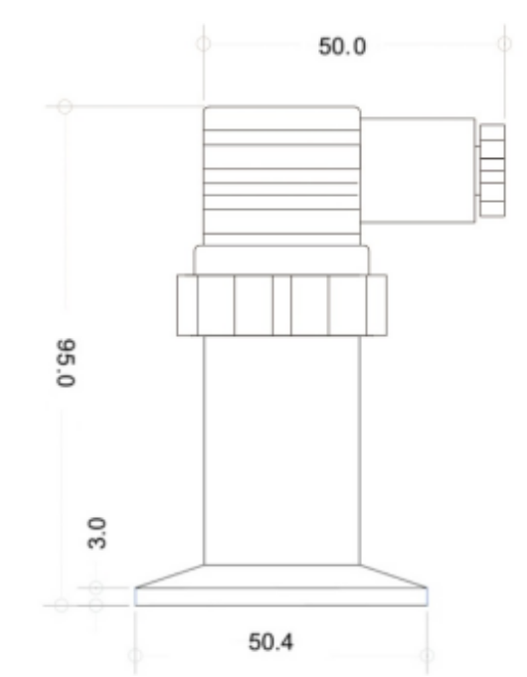
II. Technical parameters
Test medium: liquid or gas compatible with the material
Range:- Any interval within 0.1~250MPa
Accuracy level: 0.1% FS 0.25% FS 0.5%FS
Stability: ± 0.25% FS/year ± 0.5% FS/year
Output signal: 4~20mA 0~10V, RS485 communication
Working voltage: 12~36V DC (calibration: 24V ± 5%, ripple<1%)
Power supply impact: less than 0.01%/V of the output range
Working temperature:- 20~80℃
Compensation temperature:- 20~80℃
Temperature impact: ± 1.55% FS/year ± 3.0% FS/year
Overload capacity: 300%
Threaded interface: M20 * 1.5, G1/2, 1/2NPT, etc
$R=\frac{U−\text{14}}{0\text{.}\text{02}}−R_{D}$Load resistance: 4-20mA

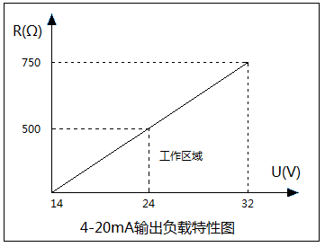
(Among them: U is the power supply voltage, RD is the internal resistance of the cable)
 Warning: It is strictly prohibited to disassemble the transmitter without authorization!
It is strictly prohibited to press the measuring element membrane with fingers!
It is strictly prohibited to insert any sharp objects into the pressure hole!

4-20mA（2 wires） | Hirschmann pin ① 24V+ | Hirschmann pin ② | Hirschmann pin ③ | Hirschman pin G
4-20mA（2 wires） | Red 24V+ | Black output | \ | \
0-10V（3 wires） | Hirschmann pin ①24V+ | Hirschmann pin ② 24V- | Hirschmann pin ③ | Hirschman pin G
0-10V（3 wires） | Brown 24V+ | Black 24V- | Blue output | \
RS485 | Hirschmann pin ①24V+ | Hirschmann pin ② 24V- | Hirschmann pin ③ A | Hirschman pin GB
RS485 | Red 24V+ | Black 24V- | Yellow A | Green B
Wire Definition

Wire installation

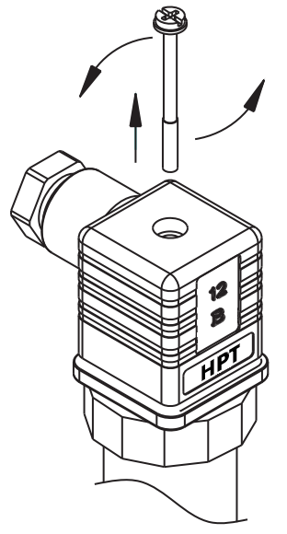
Unscrew the screw and remove the Husman connector
Use a Phillips screwdriver to pry out the junction box from the disassembly slot
Insert the cable from the outlet and connect it according to the terminal
definition corresponding to the output signal
Assemble and restore the Husman connector, and tighten the wire cap
matters needing attention
It is prohibited to measure media that are incompatible with the material
of the transmitter;
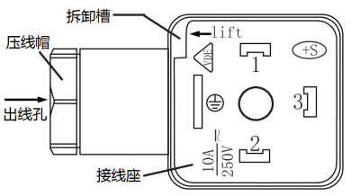
Ensure that the power supply voltage meets the product requirements
and wire according to the instructions;
The installation of the transmitter should be in a ventilated and dry place,
avoiding direct exposure to strong light and rain;
Pay attention to using snake skin pipes or iron pipes to protect the outgoing cables,
or raising the cable rack;
It is recommended to power on for at least 10 minutes to achieve optimal product performance;
Ensure that the pressure source is turned off when disassembling the transmitter to prevent the medium from spraying out;
This product is not explosion-proof and may cause major accidents when used in explosion-proof areas;

Troubleshooting

Fault phenomenon | reason | resolution
Zero point output  exceeded  accuracy error range | ·Membrane damaged  ·The back pressure pipe of the gauge type product is not  connected to the atmosphere | ·Need to return to the factory for maintenance  ·Small pressure products should use gas cables and the gas ducts should be connected to the atmosphere
The collection device has no display or displayed value  Inconsistent with actual pressure | ·Wiring error  ·The transmitter has no signal output  ·Error in calibration of output signal and pressure range | ·Check the wiring according to the wiring method  corresponding to the output signal of the transmitter ·Measure the output signal of the transmitter  ·Recalibrate the acquisition equipment according to the range and output of the transmitter label
Output signal and  actual pressure  mismatch | ·The medium or ambient temperature exceeds the specified range  ·Power supply voltage exceeds the limit  ·Excessive external load | ·Install a cooling device at the pressure inlet or move the transmitter to a low-temperature environment for retesting  ·Adjusting the power supply voltage ·Adjusting external loads
When the pressure is  constant  output irregular jump | ·The transmitter is not grounded  ·Strong on-site radio frequency interference ·Unused shielded cable | ·Use shielded cables and ground the shielding layer ·Reliable connection between transmitter and ground

After-sale service

Customers who order our products can enjoy a one-year warranty period;
If the product malfunctions during the warranty period and our company detects it as a quality issue, we will bear all the repair costs;
Damage to components or pressure diaphragms caused by failure to follow the instructions in this manual or unauthorized disassembly of the product is not covered by the product warranty.
After the product malfunctions, please contact our company and confirm the repair. Please attach the following information:
Product malfunction phenomenon;
Description of the on-site environment for product use;
Delivery address and contact information;

